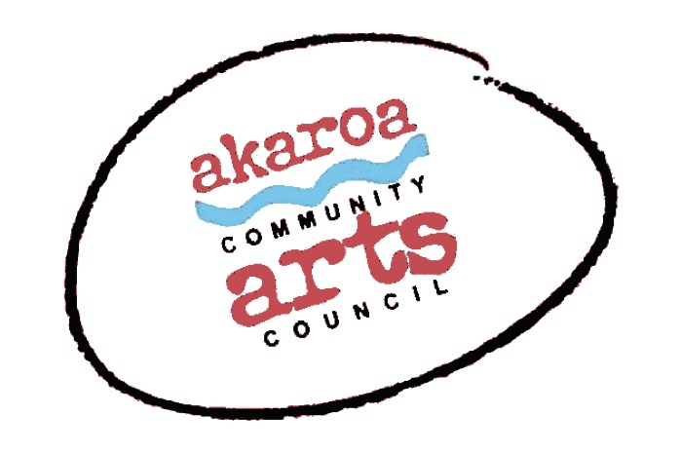
Akaroa Community Arts Council
Painting the Peninsula Landscape with Siene de Vries 2024

Registration Form

Classes: 9, 16, 23, 30 March & 6 April 2024
Start time: 10am to 4pm each day, 1-hour lunch break
Venue: Exterior locations to be advised. Weather dependent.
Course Cost: $350 for 5 classes, paid in advance or $85 per casual day

Terms
Full Payment is required in advance to secure your place
Places are limited and allocated on a receipt of payment basis.
If you are unable to attend the full course after payment for any reason, we are unable to refund your fees but will accept another artist arranged by yourself.
Internet banking is preferred to: Akaroa Community Arts Council
Account: BNZ 020832 0043919 02 Code: Oils / Reference: your name.

Provided by ACAC
A1 sheets newsprint
A3 pre-gesso’d artist’s canvas sheets
Charcoals
Brushes and turps
Primary colour oil paints, red, blue, yellow plus white and black
NOTE: We can supply 1 set of Pebeo fine oil paint; 10 colours x 20ml tubes at an extra discounted cost of $40. Please note these extra colours are NOT included in your course fee.
1 x Easel (see note below re field easels)
1 x A 1 Drawing board and clips

Things to provide yourself
Your own paint and palette if you have it (see note above)
A folding chair
An artist’s field easel if you have one; they have adjustable legs for uneven ground.
A small, portable side table to hold your paints etc – this could get messy so nothing posh!
Cotton rags to wipe brushes etc
Screw top jar to hold your turps supply for brush cleaning
Your own preferred sketching pencils etc
Packed lunch, water and thermos of hot water for your hot drinks if required.

I understand and accept the above terms and conditions.

Your Name: Phone:

Email:

Please register me for Oils with Siene de Vries 2023 – full course $350 or

(how many?) casual days at $85 each Yes / No, please supply me with 1 x set Pebeo oils at $40

Your signature: Date:

Please sign the form, electronic signature is fine, or scan it and email back to ACAC at art@akaroaarts.co.nz
Thank you, we appreciate your participation.

