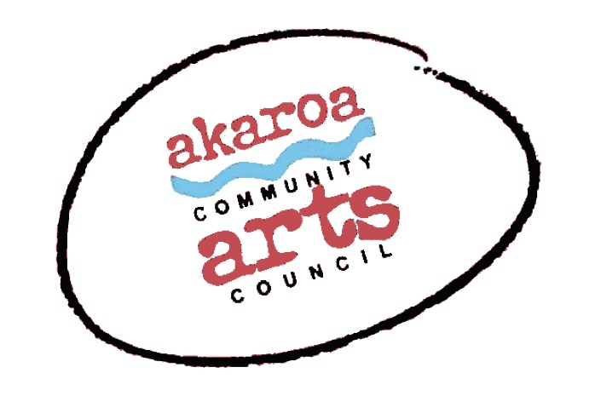
Akaroa Community Arts Council
Woodblock Printmaking with Saskia van Voorn 2023

Participant Registration Form
General Information.
Classes: 27,28,29,30 July 2023
Start time: 10am to 4pm each day, 1-hour lunch break
Venue: Trinity Church Hall, 39 Rue Lavaud, Akaroa
Course Cost: $320 for 4 sessions, paid in advance.

Terms
Full Payment is required in advance to secure your place
No refunds can be given after registration is confirmed, except for a confirmed covid infection.

NB: ACAC course fees are normally payable at the time of registration. We recognise that may not be possible for families in the current economic climate in NZ. Please contact us if you’d like to attend and pay the fee in instalments. The full fee must be paid by the class start date. Internet banking is preferred to: Akaroa Community Arts Council
Account: BNZ 020832 0043919 02 Code/Reference: Woodcuts + your name.

Places are limited and allocated on receipt of payment basis.
If you are unable to attend the full course after payment for any reason other than covid we are unable to refund your fees but will accept another artist arranged by yourself.

Provided by ACAC
all paper, transparencies etc to complete your print
3 x woodblocks per student
Printing inks to complete a three colour print
1 x Easel & chair
1 x A 1 Drawing board and clips
Tea, coffee, hot chocolate, biscuits.
*For artists who don’t have their own woodcutting tools, specifically 1 x ‘v’ and 1 x ‘u’ shaped wood gouges we can supply one of each at an extra cost of $40. Please note this is NOT included in your course fee.

Things to provide yourself
Cotton rags to wipe blocks etc.
Your own woodcutting tools if you have them
1 x old tablespoon
Your design.

I understand and accept the above terms and conditions.

Your Name: Phone:

Email:

Please register me for Woodblock Printmaking with Saskia van Voorn 2023 – full course $320

Yes / No please supply me with 2 x wood gouges, 1 x V & 1 x U shape at $40

Your signature: Date:
Please sign the form, electronic signature is fine, or scan it and email back to ACAC at art@akaroaarts.co.nz

Thank you, we appreciate your participation.

