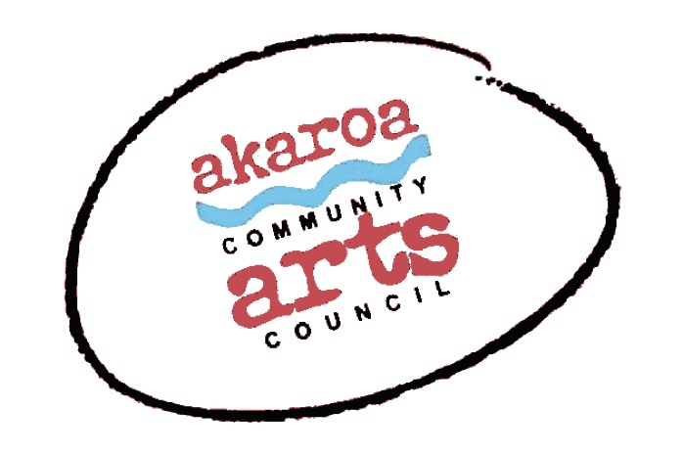
Akaroa Community Arts Council
Easel-ly Arty July 2023 – discover your stories!

Registration Form
6 and 7 July 2023
9.30 to 12 noon each day
Venue: Trinity Church Hall, Rue Lavaud, Akaroa
Course Cost: $75 for two half days, $40 for one half day – to be paid in advance.

Terms
7 years plus
Full Payment is required in advance to secure your place and allocated on a receipt of payment basis.
Internet banking is preferred: Akaroa Community Arts Council
Account: BNZ 020832 0043919 02 Code : Easel-ly-Arty Reference: your name.

If you are unable to attend the course after payment for any reason, we are unable to refund your fees but will accept another artist arranged by yourself.

Provided by ACAC
A tutor
newsprint, grey sugar and white cartridge paper
coloured pastels and charcoal
1 x Easel
1 x Drawing board

Kids - Please bring: your own drink and snacks.

grownups, feel free to stay and help

I understand and accept the above terms and conditions.

My name: My age:

My parent’s name: My parent’s ph no:

My parent’s email:

Please register me for Easel-ly Arty April2022: 6 and 7 July 2022

Or, just one day – please circle as required

My parent’s signature Date

Please sign the form, electronic signature is fine, or scan it and email back to ACAC at art@akaroaarts.co.nz

Thank you, we appreciate your participation.

