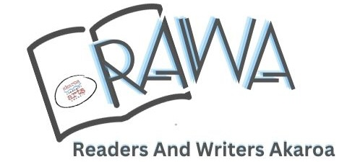
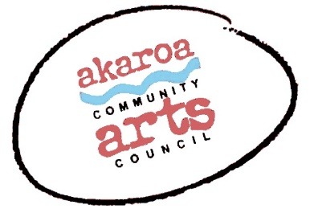
REGISTRATION FORM - WELCOME TO RAWA 2023!

Venue: The Gaiety Theatre, 105 Rue Jolie Akaroa
Date: Saturday 10 and Sunday 11 June 2023

Name: _____________________________________________________ Phone: ___________________________

Email: _____________________________________________________

INFORMATION:
RAWA is a boutique festival with a maximum of 130 participants. We hope this will provide a greater opportunity for conversation and engagement in a more relaxed setting. The strands of the RAWA programme have been designed to appeal to both readers and writers. The larger sessions (in black text) will be of interest to both, while the smaller sessions (in red text) provide practice-based workshop experiences that will appeal to people interested in developing or sharpening their writing skills and/or publishing practices.

Please indicate your preferences below and return this form to ACAC: art@akaroaarts.co.nz
Please note: The red text sessions are limited to 25 people. We will do our best to confirm your preferred sessions. In the event of your choice(s) being fully booked, we will come back to you to discuss options.

Saturday
9.00 - 11.00am  Session 1 | Mihi Whakatau, welcome and Keynote: The World of Children’s Writing  Gavin Bishop
11.30 - 1.30 pm  Session 2 | Writing across Genres  Fiona Farrell | Writing Children’s Books: Getting Organised, Getting Sorted Gavin Bishop | The Importance of Characterisation  Owen Marshall
2.30 - 4.30pm  Session 3 | Criminally good - Crime writing in Aotearoa New Zealand  Vanda Symon | The Art of Storytelling  Fiona Farrell  WORKSHOP FULL | The Image and the Word  Gavin Lang and Rodney Laredo

Sunday
9.00 - 11.00am  Session 4 | Contemporary New Zealand Literature  Mark Williams and Jane Stafford  Reviewing Books  Ray Shipley | ‘You're not in Akaroa, now, Dr Ropata’ a light hearted workshop led by former Shortland Street writer  Victor Rodger | Three Perspectives on Publishing  Heather McQuillan, Clare Corban-Banks and Rodney Laredo
11.30 - 1.30 pm  Session 5 | Three Perspectives on People and Place with Owen Marshall, Tanya Moir and John Wilson | The Bad Guys have Feelings Too - Getting to Grips with your Villain  Vanda Symon | Getting into Flash Fiction  Heather McQuillan
2.30 - 4.30pm  Session 6 | Closing address: Comforting the Disturbed, Disturbing the Comfortable  Victor Rodger  RAWA closure, Poroporoaki, and Farewell

PAYMENT

Registration $200

Please make your payment to the following bank account:

BNZ 020832 0043919 02

CODE: RAWA 2023 REFERENCE: your name

Registration includes:
- Entry to six RAWA sessions
- Morning tea on both days

Registration does not include:
- RAWA festival dinner
- Lunches
- Accommodation

THE RAWA FESTIVAL DINNER
The RAWA dinner on Saturday night will be held at Ma Maison, one of the best restaurants in Akaroa. A three course menu is planned costing $75 per head, including a complementary glass of wine on arrival (courtesy of ACAC). If you would like to attend the dinner, please book directly with Ma Maison via this link:
https://tinyurl.com/Ma-Maison

Places at the dinner are limited to 130 so book early!

TERMS AND CONDITIONS

Full payment in advance secures your place at the RAWA festival.
Your payment is non-refundable unless the festival is cancelled.
If you find you are unable to attend, we will accept a substitute registration arranged by you.

For any queries, contact us on:

art@akaroaarts.co.nz or phone 0211083554

Join us on social media:

https://www.facebook.com/AkaroaCommunityArtsCouncil

https://www.instagram.com/akaroa_community_arts_council/

HOW DID YOU HEAR ABOUT RAWA? ACAC Mailing list Akaroa Mail
facebook Book Club Library Poster

Other …………………………………

