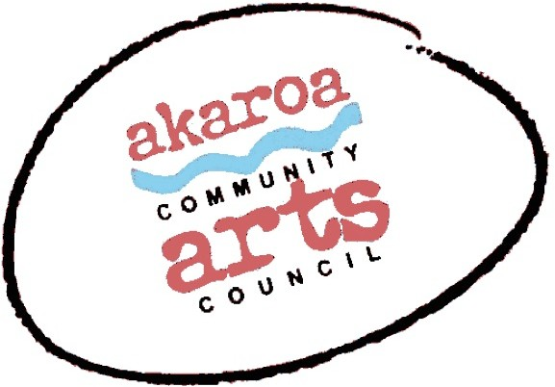

Akaroa Community Arts Council Membership

Akaroa Community Arts Council 37 Rue Balguerie, 7520
021 527184

Trust Membership Application Form

We rely on our membership, and the grants we apply for, to support our activities. Thank you for joining us in our collective support of the arts in the Banks Peninsula!

Your Name: Phone:

Email:

Address:

Category of membership (please tick)

General membership ($10 individual membership ($15 household membership)

Donor Membership | ($500), or contribution | ($ | )
Your signature: |  |  | Date:

Please return to ACAC: art@akaroaarts.co.nz

And make your deposit to the following bank account: BNZ 020832 0043919 02
CODE/REF: Membership + your name

