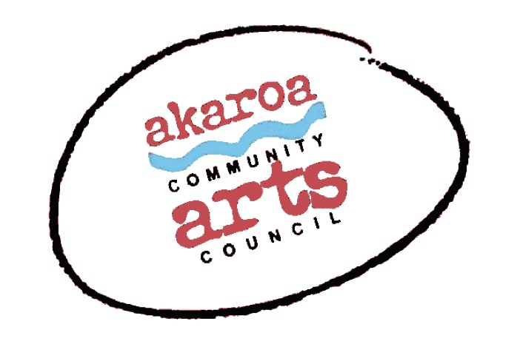
Akaroa Community Arts Council
Make a Creature Mask February 2023

Participant Registration Form
When: Saturday 4 and Sunday 5 February 2023
Time: 10am to 4pm, Lunch: 1 hour
Venue: Trinity Church Hall, Akaroa
Cost: $160 for both days – note – two days will be needed to complete your mask.

Terms
open to everyone over 12 years
no refunds can be given after registration is confirmed but another student arranged by you will be accepted in your place.
full payment is required in advance to secure your place
internet banking is preferred to: Akaroa Community Arts Council
account: BNZ 020832 0043919 02 Code/Reference: Masks + your name.
places are limited and allocated on a receipt of payment basis.

Provided by ACAC
a tutor – John Harding
all materials needed to make the mask
Tea, coffee, hot chocolate, biscuits

Please bring:
kids - your own drink and snacks
wear old clothes!

I understand and accept the above terms and conditions.

name: age: (if under 18!)

(my parents’) name: ( my parents’) contact ph. no:

(my parents’) email:

Please register me for: Make a Creature Mask: two full days

(Parents) signature Date:

Please sign the form, electronic signature is fine, scan it and email back to ACAC at art@akaroaarts.co.nz

Thank you, we appreciate your participation.

