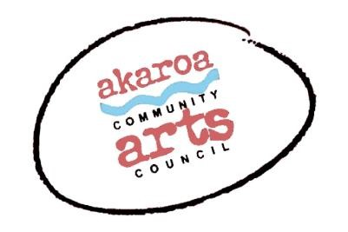
Akaroa Community Arts Council
The Art of Fiction Writing 2022 with Carl Nixon

Registration Form

Dates: Saturday July 9 and Sunday July 10, 2022
Start time: | 10am to 4pm each day, 1-hour lunchbreak
Venue: | Akaroa Boat Shed, 107 Beach Road, Akaroa.
Course Cost: | $180 for both days

Terms
Full Payment is required in advance to secure your place
Internet banking is preferred to: Akaroa Community Arts Council

Account: BNZ 020832 0043919 02

Code : Writing /Reference: your name.

Places are limited and allocated on receipt of payment basis.
If you are unable to attend the full course after payment for any reason, we are unable to refund your fees but will accept another participant arranged by yourself.

Provided by ACAC
The tutor Carl Nixon
Tea, coffee, hot chocolate, biscuits.

Please bring

Your own writing materials

I understand and accept the above terms and conditions.

Your Name: Phone:
Email:

Please register me for: The Art of Fiction Writing 2022: two days $180

Your signature: Date:

Please sign the form, electronic signature is fine, scan it and email back to ACAC at art@akaroaarts.co.nz

Thank you, we appreciate your participation.

