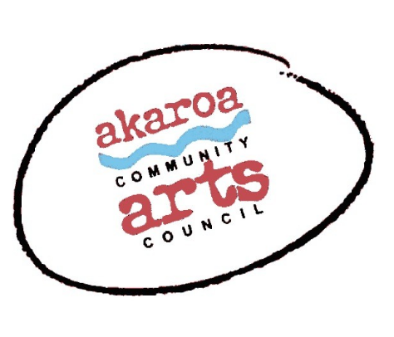
Akaroa Community Arts Council
art@akaroaarts.co.nz
Curators: John Harding – 021536016 or Kat Luper - kluper@akaroaarts.co.nz
Artist Waiver and Submission Form
The artist identified below seeks to submit artwork that he or she has created for Matariki, a Banks Peninsula community art exhibition to be held by Akaroa Community Arts Council at The ACAC Gallery, next door to the Akaroa butchery.

Submission deadline:
31 May, 2022. Full Description of Works must be submitted for consideration by email to art@akaroaarts.co.nz with a signed copy of this waiver. Details of the work including the dimensions should be completed on this form.

Exhibition Dates:
Opening 24 June, 2022 from 5.30pm to 7.30 pm, then 25 & 26 June, 2 & 3 July, 9 & 10 July, between 10am and 4pm each day.

Insurance:
Akaroa Community Arts Council (Event Organisers) and Christchurch City Council (Property Owner) cannot maintain insurance coverage on works submitted. Artists are responsible for making their own arrangements for insurance. All care will be taken of artwork during the exhibition.

Artwork Delivery and Pick Up:
The weekend of 18 & 19 June, or as agreed by ACAC. All works must be clearly labelled on the reverse with the artwork title, artist's name, ph.no, email and selling price including GST if applicable. Works must be ready to hang to the satisfaction of ACAC (will be advised upon acceptance).
Pick up will be by arrangement with Kat or John on or after the 10th July.

Commission for Sales:
If you choose to sell your work, ACAC will retain a commission of the selling price.
Members - 10%, non-members 20%. Payment will be sent to artists via internet banking within two weeks of the event closing date.

Ownership and Use of Artwork:
The artist is the owner of all artwork unless the work is sold. Artists certify that all artwork they will submit is their own original work.
The artist understands that the display of artwork at Matariki is subject to the sole discretion of ACAC. Any work may be removed from display during the exhibition to facilitate rotation of works or because of sale.
The artist agrees that ACAC may use photographs of displayed work, images of artists participating in the event, and the biographical information of the artist in marketing or media materials to promote ACAC and the Event now or in the future as ACAC chooses. Page 1|2
Authorisation:
I understand and agree to the terms above as they are written.
Artist Signature

Printed Name Date

Email

Contact Number

Bank account number:

Please note that any sales proceeds will be deposited into this nominated account.

Submission Form:

No | Title of Work | Description and Dimensions | Price
1
2
3
4

Page 2|2

