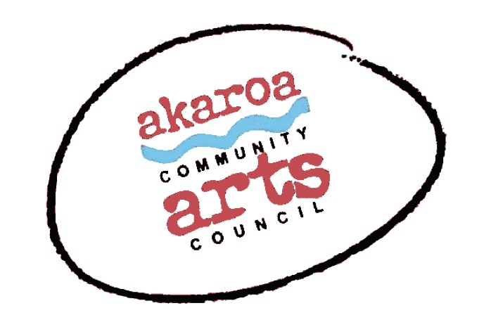
Akaroa Community Arts Council
Make A Garden Sculpture 2022

Registration Form

Dates: Saturday 9th and Sunday 10th April 2022
Start time: 10am to 4pm each day, 1-hour lunchbreak
Venue: Blythcliffe, 37 Rue Balguerie, Akaroa.
Course Cost: $160 for both days or $95 for one day

Terms
Full Payment is required in advance to secure your place. Places are limited and allocated on receipt of payment.
Internet banking is preferred to: Akaroa Community Arts Council
Account: BNZ 020832 0043919 02 Code/Reference: Garden Art + your name.
If you are unable to attend the full course after payment for any reason, we are unable to refund your fees but will accept another artist arranged by yourself.

Provided by ACAC
Tutor John Harding
Terracotta clay for your maquette
Other sculpting tools and materials
Grey cement and accelerator
Chicken wire
Potting mix for adding to concrete for the hypertufa effect
Tea, coffee, hot chocolate, biscuits.

Please bring
A spritzer for water
A trestle table / platform to work from – not your best coffee table; this will get messy!
A large tarp – big enough to cover your working area underneath your table
Rubber gloves – cement is very hard on the skin
Cotton rags to keep your sculpture damp and for your hands
An old bucket for your concrete – one of those bendy sorts, 3 times as big as a normal bucket is ideal
Another normal sized bucket for water
A lot of old newspapers for stuffing your wire shape with, prior to applying the concrete
Wooden sticks to stir your concrete in your bucket
something to share for lunch.

ACAC will run this course under the current (at the time of the workshop) Covid safety rules set by the government and the venue. We want to run a safe course for all.
At time of writing, we therefore request that all students are triple vaccinated, show their vaccine passports at registration and wear masks during the workshop. Masks may not be required if sufficient social distancing can be achieved – which it usually can We thank you for your understanding.

I understand and accept the above terms and conditions.

Your Name: Phone:

Email:

Please register me for: Make A Garden Sculpture 2022: two days $160 or one day $95 (please circle)

Your signature: Date:

Please sign the form, electronic signature is fine, scan it and email back to ACAC at art@akaroaarts.co.nz

Thank you, we appreciate your participation.

