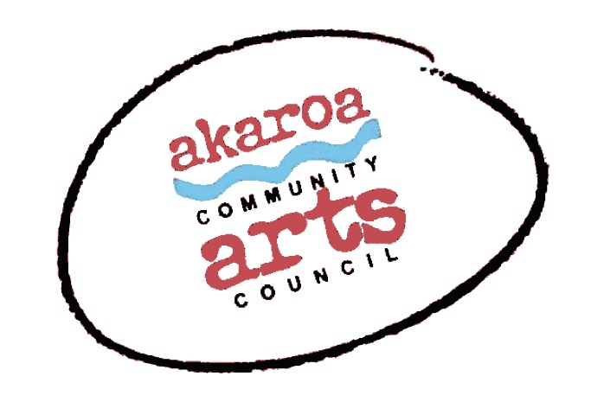
Akaroa Community Arts Council
Easel-ly Arty April 2022 – discover your whenua

Registration Form
27th and 28th April 2022
9.30 to 12 noon each day
Venue: TBA
Course Cost: $75 for two half days, $40 for one half day – to be paid in advance

Terms
7 years plus
Full Payment is required in advance to secure your place and allocated on a receipt of payment basis.
Internet banking is preferred: Akaroa Community Arts Council
Account: BNZ 020832 0043919 02 Code : Easel-ly-Arty /Reference: your name.

If you are unable to attend the course after payment for any reason, we are unable to refund your fees but will accept another artist arranged by yourself.

Provided by ACAC
A tutor
newsprint, grey sugar and white cartridge paper
coloured pastels and charcoal
1 x Easel
1 x Drawing board

Kids - Please bring: your own drink and snacks
Weather appropriate clothing – we will be working outside
Wet weather cover will be provided.

grownups, feel free to stay and help

ACAC will run this course under the current (at the time of the workshop) Covid safety rules set by the government. We want to run a safe course for all.
At time of writing, we may request that students wear masks during the workshop. We thank you for your understanding.

I understand and accept the above terms and conditions.

My name: My age:

My parent’s name: My parent’s ph no:

My parent’s email:

Please register me for Easel-ly Arty April2022: 27th and 28th April 2022

Or, just one day – please circle as required

My parent’s signature Date

Please sign the form, electronic signature is fine, or scan it and email back to ACAC at art@akaroaarts.co.nz

Thank you, we appreciate your participation.

