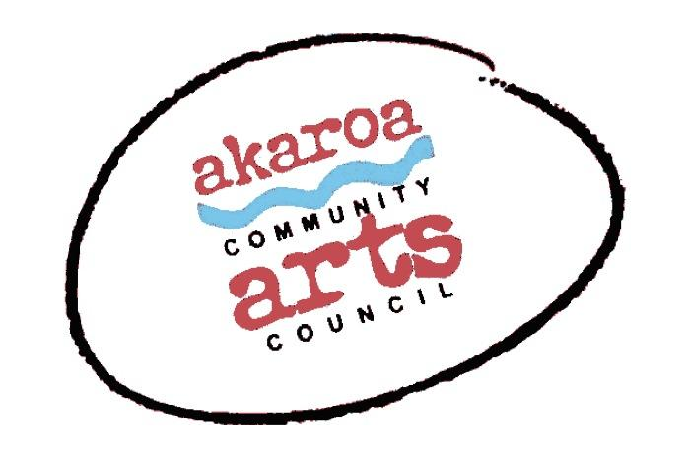
Akaroa Community Arts Council
Jubilate Singers
Registration Form

Date: Saturday, March 5th, 2022
Start time: 2:30pm to 4pm
Venue: Gaiety Theatre, Rue Jolie, Akaroa – doors open at 2pm
Ticket Cost: $20 Family,
$15 Single Adult
$10 Acac Member
$5 Student

Terms
Full Payment is required in advance to secure your ticket. Seating is limited.
Due to Covid Restrictions, Vaccine Passports are required for entry.

Internet banking is preferred to: Akaroa Community Arts Council

Account: BNZ 020832 0043919 02

Please use: Code : Jubilate / Reference: your last name.

Terms and Conditions
Tickets are limited and allocated on receipt of payment.
Your seat is not confirmed until paid for in full.
If you are unable to attend after payment for any reason, we are unable to refund your money but your ticket is transferable.
Please note that entry is given to the event via your name from our list – transferred tickets must use the booking name for entry.
Should ACAC cancel the event for any reason your ticket price is refundable.

I understand and accept the above terms and conditions.

Your Name: Phone:

Email:

Please register me for: Jubilate Singers, 5 March, 2022 at 2:30pm

Your signature: Date:

Please sign the form, electronic signature is fine, scan it and email back to ACAC at art@akaroaarts.co.nz
Thank you, we appreciate your participation.

