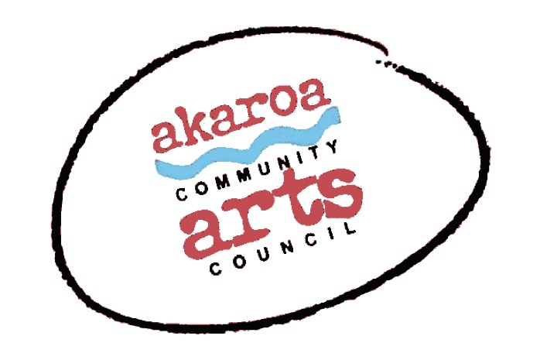
Akaroa Community Arts Council
Kura Raranga 2023
Participant Registration Form
General Information.
Classes: July 22,29, August 5,12 &13 2023
Start time: 10am to 4pm each day, 1-hour lunch break
Venue: Trinity Church Hall, 39 Rue Lavaud, Akaroa; Onuku Marae for the 12th & 13th August.
This will be a noho or sleepover.
Course Cost: $299 for the course, paid in advance or $65 per casual day

Terms
Full Payment is required in advance to secure your place – you may pay in installments – please inquire.
Internet banking is preferred to: Akaroa Community Arts Council
Account: BNZ 020832 0043919 02 Code: Raranga / Reference: your name.

Places are limited and allocated on receipt of payment basis.
If you are unable to attend the full course after payment for any reason, we are unable to refund your fees but will accept another artist arranged by yourself.

Provided by ACAC
Tea, coffee, hot chocolate, biscuits. A tutor.

Things to provide yourself
You will need a tool kit – here is a photo of Ngaio’s one –
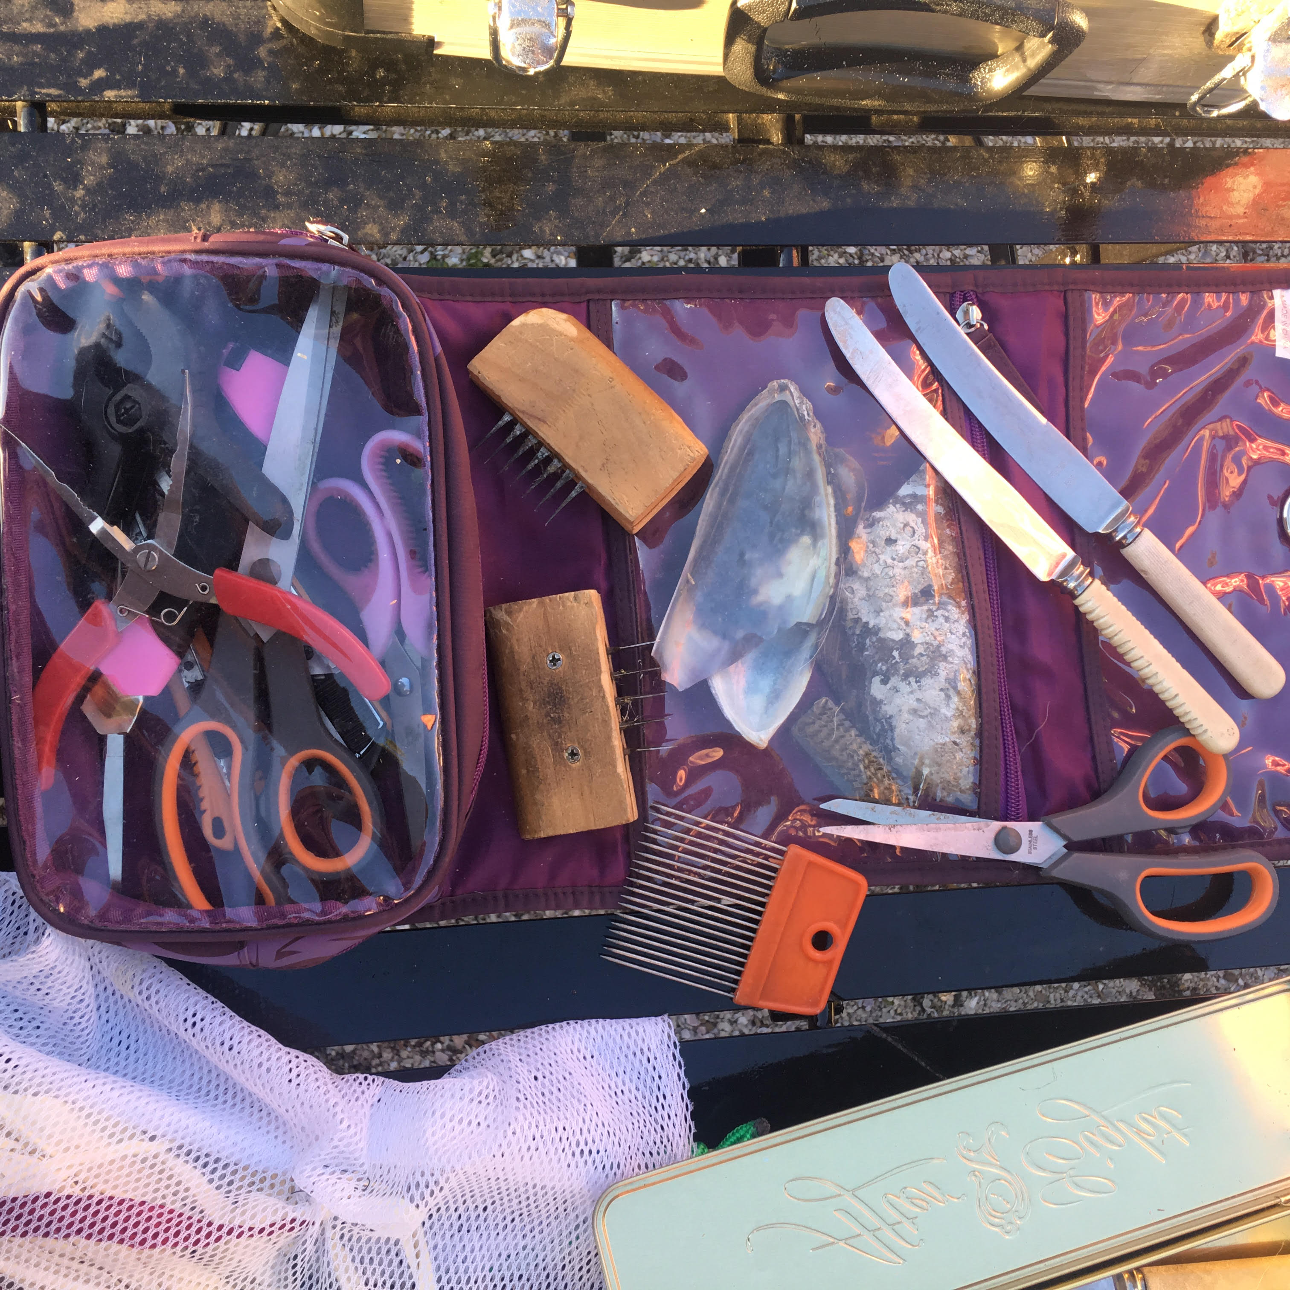
Small and larger scissors, steel toothed combs for the flax combing, a mussel shell, pliers of a couple sizes if you have them, Ngaio loves the round ended knives for various handy uses plus some large size bobby pins or the steel sort of clothes pegs x about 16 are very handy also a big, sharp kitchen knife for cutting the haraheke Plus anything else you think that you might find useful!

I understand and accept the above terms and conditions.

Your Name: Phone:

Email:

Please register me for Kura Raranga – full course $299 or (how many?) casual days at $65 each

Your signature: Date:

Please sign the form, electronic signature is fine, or scan it and email back to ACAC at art@akaroaarts.co.nz
Thank you, we appreciate your participation.

