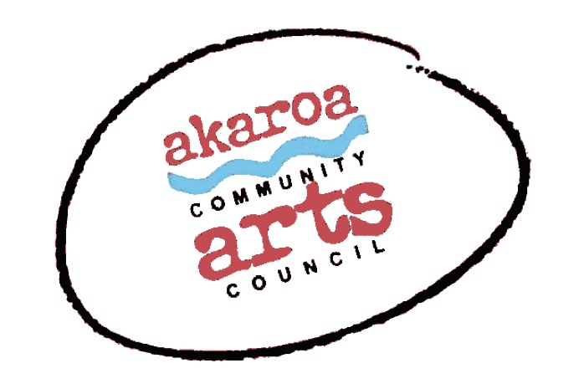
Akaroa Community Arts Council
Life alfresco March 2022

Registration Form

General Information.
Dates: Wednesday 16 and Thursday 17 March 2022
Start time: 10am to 4pm each day, 1-hour lunchbreak
Venue: tbc 0225043447
Course Cost: Free!

Terms
Participants must be fully vaccinated against Covid 19. Scanning into the Covid app and vaccination passes are required for entry.
We will be outside – wet weather cover on the day will be advised but will be under a balcony or the like, not in an enclosed room.

Provided by ACAC
A1 sheets newsprint
A1 white cartridge paper
Charcoals
1 x Easel
1 x A 1 Drawing board
Tea, coffee, milo, biscuits.
Please bring something to share for lunch.

To bring yourself
A chair
Your own painting materials
ACAC will provide primary oil colours, brushes and primed canvas
A small jar for your turps if youre painting with oils
Your own drinks and lunches

I understand and accept the above terms and conditions.

Your Name: Phone:

Email:

Please register me for: Life alfresco March 2022:

(please circle and indicate which day you’ll attend)

Your signature: Date:

Please sign the form, electronic signature is fine, scan it and email back to ACAC at art@akaroaarts.co.nz

My vaccine pass is attached.

Thank you, we appreciate your participation.

