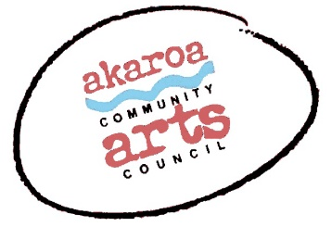
Akaroa Community Arts Council
PO Box 166, Akaroa 7542
022 5043447
Anne Moore – curator.
art@akaroaarts.co.nz
Artist Waiver and Submission Form
The artist identified below seeks to submit for display artwork that he or she has created in ‘Unlimited In Paradise’, a community art exhibition to be held by Akaroa Community Arts Council at The ACAC Gallery, next door to the Akaroa butchery.
Submission deadline:
1st October 2021. Works must be submitted for consideration by email to art@akaroaarts.co.nz with a signed copy of this waiver and details of the work including the dimensions completed on this form.
Exhibition Dates:
Opening 12 November 5.30 to 7.30 pm then 13/14; 20/21; 27/28 November; and 4/5 December 2021 between 10am and 4pm each day.
Insurance:
Akaroa Community Arts Council (Event Organisers) and Christchurch City Council (Property Owner) cannot maintain insurance coverage on works submitted. Artists are responsible for making their own arrangements for insurance. All care will be taken of artwork during the exhibition.
Artwork Delivery and Pick Up:
The weekend of 6 and 7 November or as agreed by ACAC. All works must be clearly labelled on the reverse with the artwork title, artists name, ph.no, email and selling price including GST if applicable. Works must be ready to hang to the satisfaction of ACAC (will be advised upon acceptance).
Commission for Sales:
If you choose to sell your work, ACAC will retain commission of the selling price.
Members - 10%, non-members 20%. Payment will be sent to artists via internet banking within two weeks of the event closing date.
Ownership and Use of Artwork:
The artist is the owner of all artwork unless the work is sold. Artists certify that all artwork they will submit is their own original work.
The artist understands that the display of artwork at Unlimited In Paradise is subject to the sole discretion of ACAC. Any work may be removed from display during the exhibition to facilitate rotation of works or because of sale.
The artist agrees that ACAC may use photographs of displayed work, images of artists participating in the event, and the biographical information of the artist in marketing or media materials to promote ACAC and the Event now or in the future as ACAC chooses.

Authorisation:
I understand and agree to the terms above as they are written.
Artist Signature Date

Printed Name Contact Number

Email

Bank account number:
please note that any sales proceeds will be deposited into this nominated account.

Submission Form:

No | Title of work | Description – eg – sculpture / oil painting / and dimensions | Selling price | Office use only
1
2
3
4

