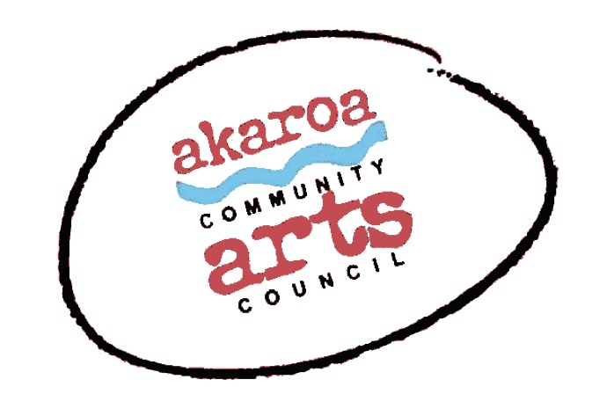
Akaroa Community Arts Council
Oil Painting with Siene de Vries 2021

Participant Registration Form

Classes: 31 July, 7, 14, 21, 22 August 2021
Start time: 10am to 4pm each day, 1-hour lunch break
Venue: Trinity Church Hall, 39 Rue Lavaud, Akaroa
Course Cost: $380 for 5 classes, paid in advance or $85 per casual day

Terms
Full Payment is required in advance to secure your place
No refunds can be given after registration is confirmed.
Internet banking is preferred to: Akaroa Community Arts Council
Account: BNZ 020832 0043919 02 Code: Oils / Reference: your name.

Places are limited and allocated on receipt of payment basis.
If you are unable to attend the full course after payment for any reason, we are unable to refund your fees but will accept another artist arranged by yourself.

Provided by ACAC
A1 sheets newsprint
A3 pre-gesso’d artist’s canvas sheets
Charcoals
Brushes and palette and turps
1 x Easel & chair
1 x A 1 Drawing board and clips
1 x life model for 17 and 18 October
Tea, coffee, hot chocolate, biscuits.
*For artists who don’t have their own oil paint we can supply 1 set of Pebeo fine oil paint; 10 colours x 20ml tubes at an extra cost of $30. Please note this is NOT included in your course fee.

Things to provide yourself
A small side table to hold your paints etc – this could get messy so nothing posh!
Cotton rag to wipe brushes etc
Screw top jar to hold your turps supply for brush cleaning
Your own paint if you have it
Your own preferred sketching pencils etc

I understand and accept the above terms and conditions.

Your Name: Phone:

Email:

Please register me for Oils with Siene de Vries 2021 – full course $380 or

(how many?) casual days at $85 each Yes / No, please supply me with 1 x set Pebeo oils at $30

Your signature: Date:

Please sign the form, electronic signature is fine, or scan it and email back to ACAC at art@akaroaarts.co.nz

Thank you, we appreciate your participation.

