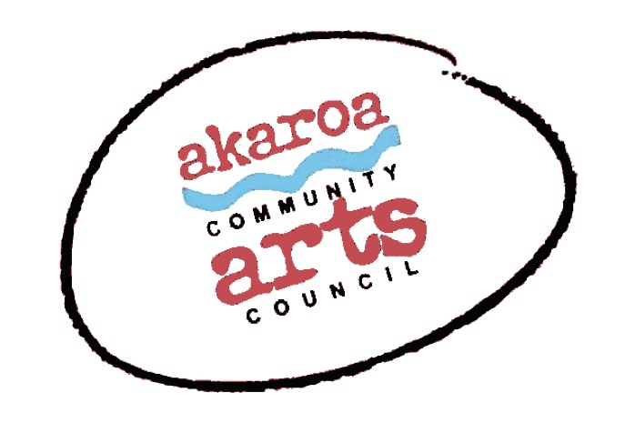
Akaroa Community Arts Council
Make A Garden Sculpture 2021

Registration Form

Dates: Saturday April 17th & Sunday18th 2021
Start time: 10am to 4pm each day, 1-hour lunchbreak
Venue: Blythcliffe, 37 Rue Balguerie, Akaroa.
Course Cost: $160 for both days or $90 for one day

Terms
Full Payment is required in advance to secure your place
Internet banking is preferred to: Akaroa Community Arts Council
Account: BNZ 020832 0043919 02 Code : Garden Art /Reference: your name.
Places are limited and allocated on receipt of payment basis.
If you are unable to attend the full course after payment for any reason, we are unable to refund your fees but will accept another artist arranged by yourself.

Provided by ACAC
The tutor John Harding
Terracotta clay for your maquette
Other sculpting tools and materials
Grey cement, accelerator
Chicken wire
Potting mix for adding to concrete for the hypertufa effect
Tea, coffee, hot chocolate, biscuits.

Please bring
A spritzer for water
A trestle table / platform / box to work from
A large tarp – big enough to cover the working area underneath your table
Rubber gloves – cement is very hard on the skin
Cotton rags to keep your sculpture damp and for your hands
An old bucket for your concrete – one of those bendy sorts, 3 times as big as a normal bucket is ideal
Another normal sized bucket for water
A lot of old newspapers for stuffing your wire shape with, prior to applying the concrete
Wooden sticks to stir your concrete in your bucket
something to share for lunch.

I understand and accept the above terms and conditions.

Your Name: Phone:

Email:

Please register me for: Make A Garden Sculpture 2020: two days $160

Your signature: Date:

Please sign the form, electronic signature is fine, scan it and email back to ACAC at art@akaroaarts.co.nz

Thank you, we appreciate your participation.

