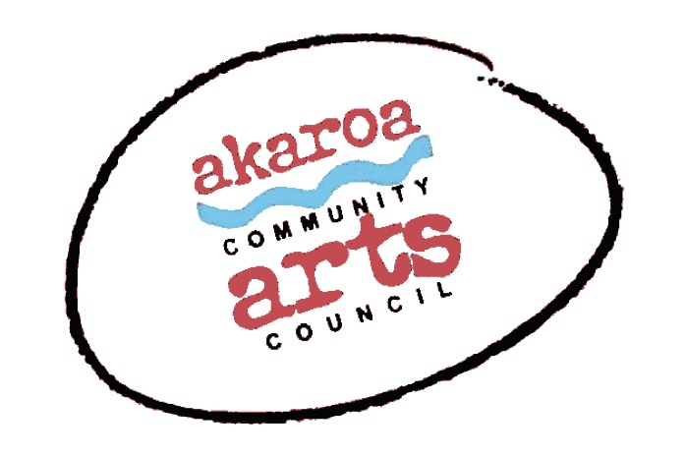
Akaroa Community Arts Council
An Evening with Owen Marshall
Registration Form

Date: Friday June 4, 2021
Start time: 7 to 8.30pm
Venue: Gaiety Theatre, Rue Jolie, Akaroa – doors and CASH bar opens at 6.30pm
Ticket Cost: $25

Terms
Full Payment is required in advance to secure your ticket

Internet banking is preferred to: Akaroa Community Arts Council

Account: BNZ 020832 0043919 02

Please use:

Code : OwenMarshall / Reference: your name.

Terms and Conditions
Tickets are limited and allocated on receipt of payment basis.
Your seat is not confirmed until paid for in full.
If you are unable to attend after payment for any reason, we are unable to refund your money but your ticket is transferrable.
Please note that entry is given to the event via your name from our list – transferred tickets must use the booking name for entry.
Should ACAC cancel the event for any reason your ticket price is refundable.

I understand and accept the above terms and conditions.

Your Name: Phone:

Email:

Please register me for: An Evening with Owen Marshall, June 4th 2021 at 7pm; $25

Your signature: Date:

Please sign the form, electronic signature is fine, scan it and email back to ACAC at art@akaroaarts.co.nz

Thank you, we appreciate your participation.

