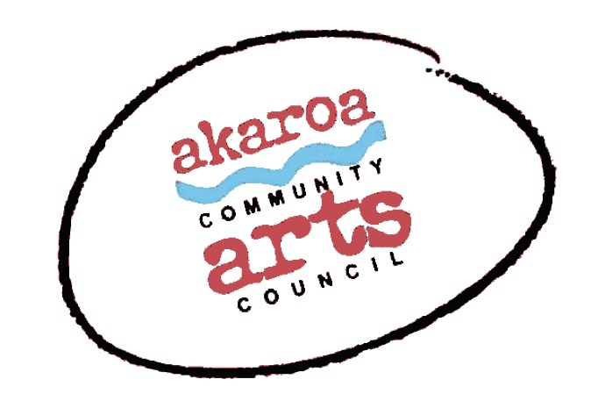
Akaroa Community Arts Council
Easel-ly Arty – Discover Your Mirror Image! July 2021

Registration Form
22 and 23 July 2021
9.30 to 12 noon each day
Venue: Presbyterian Church Hall, Akaroa
Course Cost: $70 for two days, $40 for one day – to be paid in advance

Terms
8 years plus
Full Payment is required in advance to secure your place
Internet banking is preferred: Akaroa Community Arts Council
Account: BNZ 020832 0043919 02 Code : Easel-ly-Arty /Reference: your name.

Places are limited and allocated on receipt of payment basis.
If you are unable to attend the course after payment for any reason, we are unable to refund your fees but will accept another artist arranged by yourself.

Provided by ACAC
A tutor
A1 sheets newsprint, A1 grey sugar paper
coloured pastels and charcoal
1 x Easel & chair
1 x A 1 Drawing board
Tea, coffee, hot chocolate, biscuits for grownups, feel free to stay and help

Kids - Please bring: your own drink and snacks

I understand and accept the above terms and conditions.

My name: My age:

My parent’s name: My parent’s ph no:

My parent’s email:

Please register me for Easel-ly Arty : 22 and 23 July 2021

Or, just one day – please circle as required

My parent’s signature Date

Please sign the form, electronic signature is fine, or scan it and email back to ACAC at art@akaroaarts.co.nz

Thank you, we appreciate your participation.

