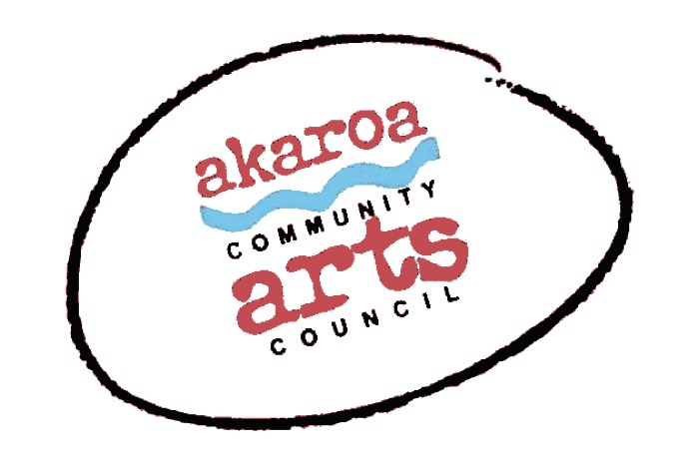
Akaroa Community Arts Council
Life Drawing Masterclass 2021

Student Registration Form
20 and 21 June 2021
10am to 4pm each day, 1 hour lunchbreak
Trinity Church Hall, Akaroa
$199 for both days, paid in advance or $120 for one day

Terms
Full Payment is required in advance to secure your place.
No refunds will be given after registration is confirmed.
Internet banking is preferred to: Akaroa Community Arts Council
Account: BNZ 020832 0043919 02
Particulars – student name
Code – Masterclass
Reference – feb21

Places are limited and allocated on receipt of payment basis.
If you are unable to attend the full course after payment for any reason, we are unable to refund your fees but will accept another artist arranged by yourself.

Provided by ACAC
One male or female model per class - Note: models will be fully nude for all classes.
A1 sheets newsprint
A1 white cartridge paper
Charcoals
1 x Easel & chair
1 x A 1 Drawing board
Tea, coffee, hot chocolate, biscuits.

I understand and accept the above terms and conditions.

Your Name: Phone:

Email:

Please register me for: Life Drawing Masterclass 2021

two days $199 or one day $120

Please circle your choice & indicate which day you’ll attend if reg. is for a one day option.

Your signature: Date:

Please sign the form, electronic signature is fine, or scan it and email back to ACAC at art@akaroaarts.co.nz

Thank you! ACAC appreciates your support

