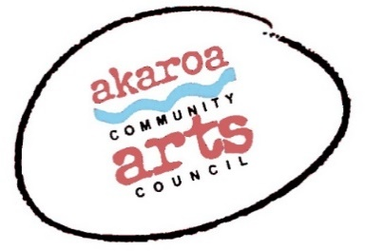
Woodblock Printing with Saskia van Voorn.
Student information sheet
https://www.saskiavanvoorn.com/
During the three-day course students will be guided through the process of making a colour woodblock print from start to finish. Students will learn the technical aspects of carving, using a variety of gouges. On day two and three we will be mixing inks, inking and printing the different blocks.
Working with the inks can be quite messy so it is advisable to wear older clothes or to bring an apron.
Things to bring –
1 - your drawing / design. It should be no more than 26cm x 20cm - it can be smaller. The design will be adapted and “picked apart” to make it suitable for the three blocks that we are going to work with. Getting the registration right with multiple blocks is something that we will pay special attention to. Here is an example of the sort of three colour print that you could be aiming for. Saskia is happy to help guide you with your design choice prior to the course start. Just email Lesley with your questions and she will put you in touch:)
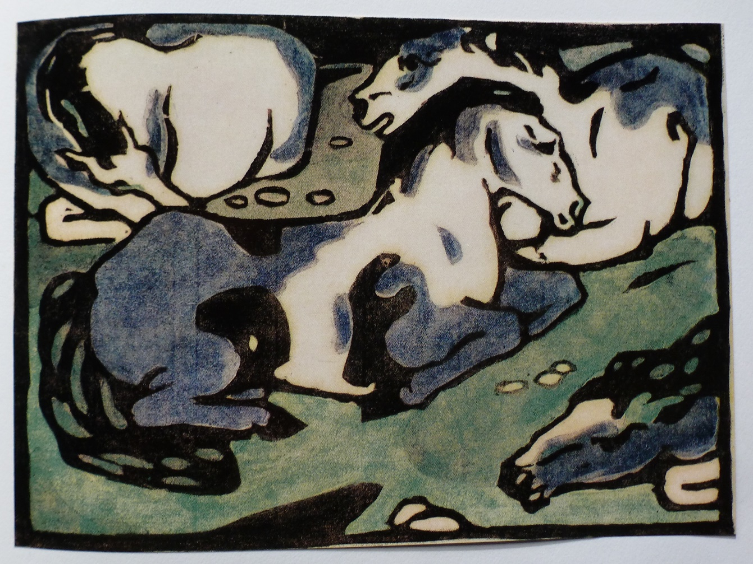
Horses Lying Down by Franz Marc.

2 – your own pencils, colours etc for continuing work on your designs.

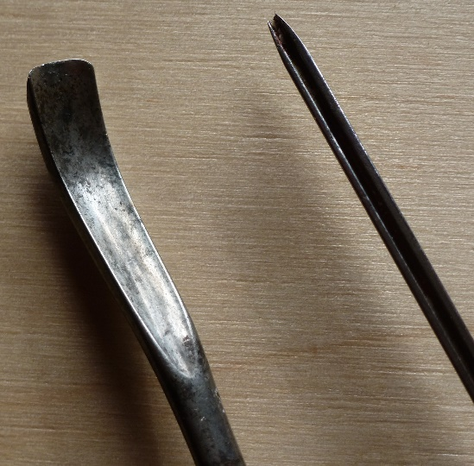
3 - your own woodcutting gouges if you have them. We can provide students with a ‘v’ and a ‘u’ shape for you to purchase at extra cost if needed.

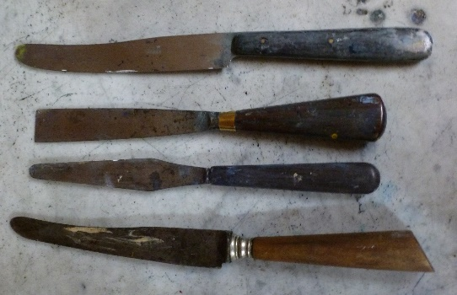
4 - a few old flexible knives or palette knives

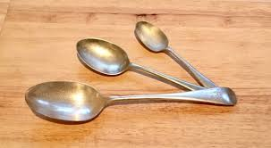
5 - an old tablespoon and / or two or three other spoon sizes.

