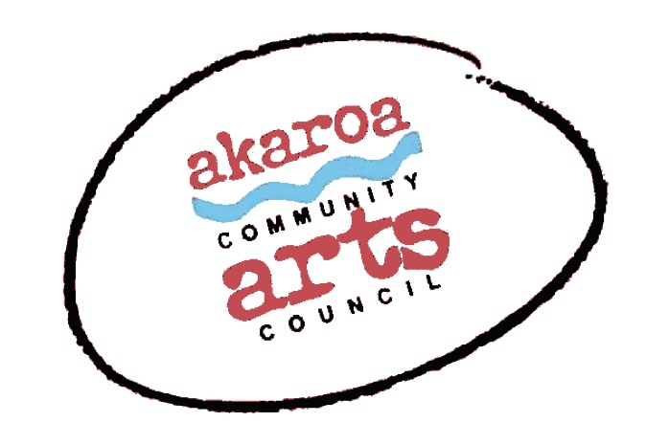
Akaroa Community Arts Council
Life alfresco jan 2021

Participant Registration Form

General Information.
Dates: Wednesday 27th and Thursday 28th 2021
Start time: 10am to 4pm each day, 1-hour lunchbreak
Venue: Anne Moore & John Thacker’s garden 210 Bells Road, Takamatua.
Course Cost: $80 for both days or $50 for one day

Terms
Full Payment is required in advance to secure your place
No refunds will be given after registration is confirmed.
Internet banking is preferred to: Akaroa Community Arts Council
Account: BNZ 020832 0043919 02 Code/Reference: Life alFresco + your name.

Places are limited and allocated on receipt of payment basis.
If you are unable to attend a class, no refund is able to be made.
If you are unable to attend the full course after payment for any reason, we are unable to refund your fees but will accept another artist arranged by yourself.

Provided by ACAC
One male or female model per class - Note: models will be fully nude for all classes.
A1 sheets newsprint
A1 white cartridge paper
Charcoals
1 x Easel & chair
1 x A 1 Drawing board
Tea, coffee, hot chocolate, biscuits.
Please bring something to share for lunch.

I understand and accept the above terms and conditions.

Your Name: Phone:

Email:

Please register me for: Life alfresco: two days $80 OR

one day $50 (please indicate weds or Thurs)

Your signature: Date:

Please sign the form, electronic signature is fine, scan it and email back to ACAC at art@akaroaarts.co.nz

Thank you, we appreciate your participation.

